**Student** Name:Jayabharath,Jeeva,Kathir,Kathiravan

**Register No:**511923205020,511923205021,511923205023,511923205024

**Institution:** Priyadarshini Engineering College

**Department:** B.Tech -IT

**Date of Submission:05/05/2025**

**Github Repository Link:[]**

**1.Problem Statement**

Expensing the truth : This is a powerful and evocative phrase. It suggests that the proliferation of fake news comes at a significant cost to truth, accuracy, and potentially societal well-being. It implies that truth is being eroded or diminished by the prevalence of falsehoods.

* advanced fake news detection : This clearly identifies the core technological domain aimed at addressing the problem. The term "advanced" suggests the need for sophisticated techniques that go beyond simple keyword matching or basic fact-checking.
* powered by natural language processing : This specifies the primary technology driving the fake news detection efforts. Natural Language Processing (NLP) is a field of artificial intelligence that focuses on enabling computers to understand, interpret, and generate human language. This is crucial for analyzing the nuances of text, identifying subtle cues of deception, and understanding the context of information.

**2. Project Objectives**

Develop a user-friendly interface for accessing and interpreting detection results:

* Create an accessible platform or tool that allows users (e.g., journalists, researchers, general public) to input text or news articles and receive a clear and understandable assessment of its likelihood of being fake news.
* The interface should also provide insights into the reasoning behind the classification, highlighting the linguistic cues or factual discrepancies identified.
* Example: Build a web application where users can paste a news article URL or text and receive a probability score indicating the likelihood of it being fake, along with a summary

of the key indicators that contributed to the score (e.g., "highly emotional language," "unverified sources cited").

**3.Flowchart of The Project Workflow**

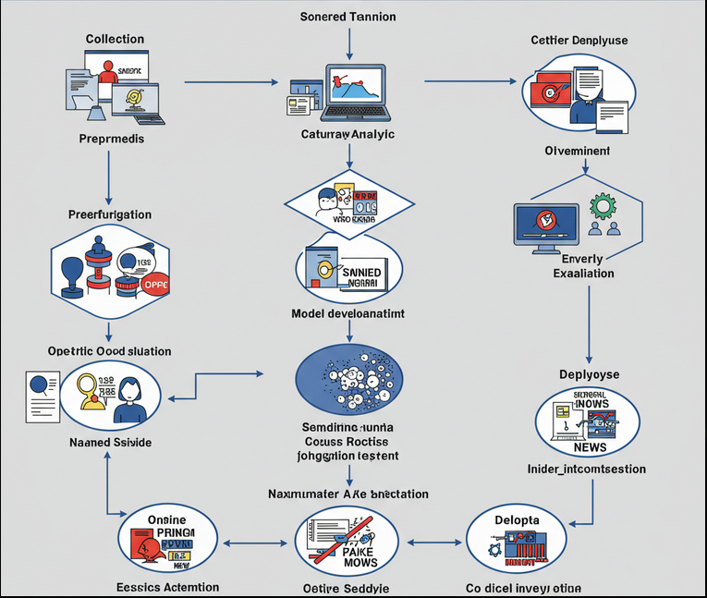

**4.Data Description**

Content:

* Full Text of Articles: The complete body of the news article, including headlines, subheadings, and all paragraphs. This allows the NLP models to learn linguistic patterns and semantic nuances.

Metadata:

* Source: The name of the news outlet or website from which the article originated. This is crucial for assessing source credibility.
* Publication Date and Time: Helps in understanding the temporal context and identifying potential anomalies.
* Author (if available): Can be used to track author reputation or identify potential patterns.

Labeling:

Binary Labels: Each article should be clearly labeled as either "True" or "Fake."

Ground Truth Source: Information about how the label was determined (e.g., fact-checking organization verification, journalistic consensus). This ensures the reliability of the labels.

5.Data Preprocessing

Before using any of this data to train a model, several preprocessing steps are typically required

* Text Cleaning: Removing irrelevant characters, HTML tags, and noise.
* Tokenization: Breaking down text into individual words or sub-word units.
* Lowercasing: Converting all text to lowercase to ensure consistency.
* Stop Word Removal: Eliminating common words (e.g., "the," "a," "is") that may not carry significant meaning.
* Stemming/Lemmatization: Reducing words to their root form to normalize vocabulary.

**6.exploratory data analysis (EDA)**

* Understand the Data: Gain insights into the structure, content, and quality of our datasets containing both real and fake news.
* Identify Patterns and Differences: Discover distinguishing features and patterns in the language, style, and content that differentiate fake news from genuine news.
* Formulate Hypotheses: Develop informed hypotheses about the linguistic and textual characteristics that are indicative of fake news, which can then guide feature engineering and model development.
* Guide Feature Engineering: Identify potentially useful features that can be extracted from the text using NLP techniques to train effective detection models.
* Assess Data Quality: Detect inconsistencies, missing values, or biases within the datasets that might impact the performance of the detection models.
* Visualize Differences: Create visualizations to effectively communicate the key differences between real and fake news data.

7.Feature Engineering

Sentiment Features:

* Overall Sentiment Score: Calculate the overall sentiment (positive, negative, neutral) of the article using sentiment analysis tools. Fake news often employs highly emotional language to manipulate readers.
  + Example: A score of 0.8 for "very positive" or -0.7 for "very negative."

Complexity and Readability Features:

* Flesch Reading Ease: Measures the readability of the text. Very low or very high scores might be indicative of manipulation.
  + Example: A score of 30 (very difficult to read) or 90 (very easy to read).

Lexical Features:

* Presence of Stop Words: The frequency of stop words (e.g., the, a, is) might differ.
  + Example: Ratio of stop words to total words.

Syntactic Features:

* Part-of-Speech (POS) Tag Frequencies: The distribution of different POS tags (e.g., nouns, verbs, adjectives) can vary between real and fake news.
  + Example: Ratio of nouns to verbs, or frequency of adverbs.

8.Model Building

Key Stages in Model Building:

* + Data Sources: Gathering a diverse and representative dataset of both genuine and fake news articles is essential. Potential sources include:
  + Reputable News Outlets: Articles from well-established and fact-checked news organizations (e.g., Reuters, Associated Press, BBC, The Hindu)
  + Fact-Checking Websites: Datasets from organizations that actively debunk fake news (e.g., Snopes, PolitiFact, FactCheck.org). These often provide labeled examples of both true and false claims.
  + Archived News Data: Historical news data can help the model learn patterns that are consistent across different time periods.

**9.Visualization of Results & Model Insights**

Visualizing Detection Results:

1. Probability Score and Confidence Level:
   * Visualization: A gauge or a progress bar indicating the probability (e.g., 0-100%) of the content being fake. Alongside, display a confidence level (e.g., low, medium, high) to reflect the model's certainty in its prediction.
   * Insight: Provides a quick and intuitive understanding of the system's assessment and the reliability of that assessment.
2. Categorization of Fake News (if applicable):
   * Visualization: If the model can categorize different types of fake news (e.g., misinformation, disinformation), use a pie chart or a stacked bar chart to show the distribution of these categories in a dataset or for a specific piece of content.
   * Insight: Helps users understand the nature of the identified fake news.

Visualizing Model Insights:

1. Feature Importance:
   * Visualization: Use bar charts or word clouds to display the importance of different linguistic features (e.g., specific words, n-grams, sentiment scores, part-of-speech tags) in the model's classification process.
   * Insight: Reveals which aspects of the language are most indicative of fake news according to the model.
2. Attention Mechanisms (for Transformer Models):
   * Visualization: Visualize the attention weights of transformer models, showing which words in the input text the model is focusing on when making a prediction. This can be done using heatmaps overlaid on the text.
   * Insight: Provides a granular view of the model's focus and helps understand which parts of the sentence are most influential in the classification.

**10.Tools And Technologies Used**

Core Technologies:

1. Natural Language Processing (NLP) Libraries and Frameworks
2. Machine Learning (ML) Algorithms
3. Data Storage and Management
4. Cloud Computing Platforms (Optional but Highly Likely

Specific Techniques and Tools within NLP

1. Text Representation
2. Feature Engineering
3. Fact-Checking and Knowledge Integration
4. Source Credibility Assessment
5. Explainable AI (XAI) Tools and Techniques
6. Data Visualization Tools
7. Deployment and Monitoring Tools

11.Team Members and Contribution

JAYA BHARATH**-problem statement, project objectives and flow chart of the workflow**

JEEVA-data description,data processing and (EDA)

KATHIR-feature engineering and model building

KATHIRAVAN-visualization of result & model insights and tools and technologies used

THANK YOU